SFX A Level Politics
Year 11 Taster activities
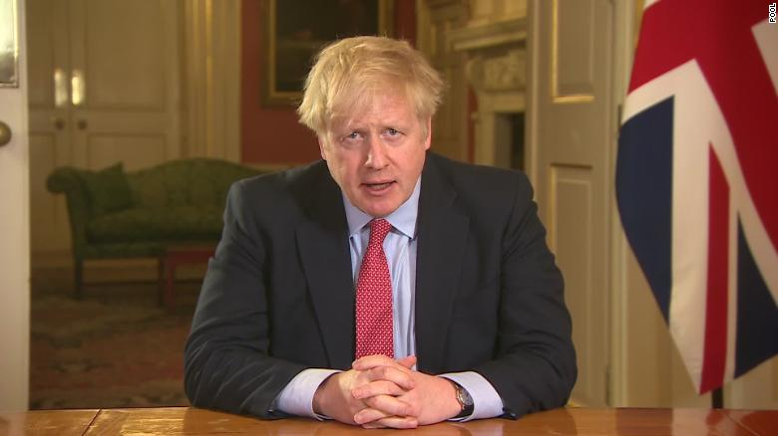
This job is a lot harder than I expected…
Welcome, year 11! This is an opportunity to practice some tasks and activities for A level Politics, should you choose to take this September. The pack is designed to give you a flavour of what A level Politics is all about. The activities will introduce you to some core political concepts and events, to aid your understanding of politics ready for sixth form. Don’t feel you need to complete it all in one go! You can complete the tasks in this booklet in the spaces provided. You can send your answers andany questions back to r.shakes@sfx.ac.uk , and we'll get back to you.
- Ms Shakes and Ms Hardy

What is A level Politics?
Lively, relevant, controversial… there are many ways to describe A-level Politics. There’s no denying that it’s one of the most interesting and engaging qualifications you can choose. Lively, relevant, controversial… there are many ways to describe A-level Politics. There’s no denying that it’s one of the most interesting and engaging qualifications you can choose.
Covering news and current affairs from the UK and US, it helps you understand how the UK country is run and develops research, written communication and debate skills. It also helps grow your confidence.

A Level course outline
Year 12: UK Politics | Year 12-13: Ideologies | Year 13: US Politics
UK Constitution, Parliament & Prime Minister | Liberalism | US Constitution, Congress & Presidency
UK Democracy | Conservatism | US Democracy
UK Parties | Socialism | US Parties
UK Elections & Voting | Feminism | US Elections & Voting

Task One: What is Politics?
“Politics is the study of how a people, a nation or a state is governed.”
When most people think of politics, they think of old, wealthy men (only sometimes women, and only sometimes ethnic minorities) in offices, making deals and agreements that will affect millions of people, just for personal gain. And it’s true that some decisions are made that way, but politics is much more than that.
Politics is about power, about people, equality, war, conflict, debate, cooperation, freedom, money, etc. – it’s about the relationship between the state (the government) and its citizens, or the state and other states. It governs everything we can and will do in our lives.
One of the reasons politics is so exciting is that it changes every single day based on the actions of individuals. Less than 500 people (in a country of 330 million) decided the result of the 2000 presidential election that made George Bush president. In 2001 he invaded Afghanistan and in 2003 he invaded Iraq. These two things have changed the Middle East and global politics, perhaps forever. Closer to home, if just one out of every 50 people who voted to leave the EU had voted differently, we wouldn’t have left. Each individual vote is vital, and yet 28% of all the people who could vote and registered to vote in that referendum didn’t turn out on June 23rd. It would take just a small number of them to change the result.
Your first task is to help you garner an understanding of what Politics is really all about. Use the internet (e.g. Wikipedia, YouTube and other sources) to research and understand what the following key terms mean and create a short definition for each in your own words.
You are welcome to try to get your families involved in this – they may have some understanding of these concepts already! The most important thing in an A level is your understanding – so it’s not about having the “right” or “word-perfect” definition, it’s about you understanding what a concept means
Term | Explanation
Power
Authority
Legitimacy
Government
Politics
Civil society
Executive branch
Prime minister
Cabinet
Legislative branch
Parliament
House of Commons
House of Lords
Judicial branch
Supreme Court (UK – not US!)
Rule of Law
Westminster Model
Elective dictatorship
Direct democracy
Representative democracy
Sovereignty
Parliamentary sovereignty
Referendum (UK – not US!)
Constitutional monarchy
Fusion of powers
Separation of powers
Devolution
Labour Party
Conservative Party
Liberal Democrats
Brexit Party
Presidency (USA)
Congress (USA)
Constitution (USA)
Checks & Balances (USA)
Supreme Court (USA)
Republican Party (USA)
Democratic Party (USA)
Liberalism (Ideology)
Conservatism (Ideology)
Socialism (Ideology)
Nationalism (Ideology)

Task Two: British Politics
Go to these links here for the UK’s three major parties:
https://www.bbc.co.uk/news/election-2019-50524262
https://www.bbc.co.uk/news/election-2019-50501411
https://www.bbc.co.uk/news/election-2019-50459123
These links summarise their key manifesto policies in the 2019 general election, which you may remember voting in at school. I would like you to choose a few policies of your choose and explain below why you support OR do not support that policy. You must choose at least 1 policy from each manifesto to discuss your agreement to or opposition to (therefore compulsory is to do 3) – if you want to extend yourself and go further, you can do more than 3 by copying and pasting the spaces I have provided.
Party: __________________________
Manifesto policy: _____________________________________________________________________________________________________________________________________________________________________________________________________________________________________________________________________
Agree/disagree & why:
__________________________________________________________________________________________________________________________________________________________________________________________________________________________________________________________________________________________________________________________________________________________________________________________________________________________________________________________________________________________________________________________________________

Party: __________________________
Manifesto policy: _____________________________________________________________________________________________________________________________________________________________________________________________________________________________________________________________________
Agree/disagree & why:
__________________________________________________________________________________________________________________________________________________________________________________________________________________________________________________________________________________________________________________________________________________________________________________________________________________________________________________________________________________________________________________________________________

Party: __________________________
Manifesto policy: _____________________________________________________________________________________________________________________________________________________________________________________________________________________________________________________________________
Agree/disagree & why:
__________________________________________________________________________________________________________________________________________________________________________________________________________________________________________________________________________________________________________________________________________________________________________________________________________________________________________________________________________________________________________________________________________
Next I want you to conduct some research into the role of your local MP.
I would like you to find out who your local MP is and the following details about them:
MP’s name:
Political party:
Constituency (the area they represent):
Areas they have a particular interest in:
And finally, look at their voting record (found here https://www.theyworkforyou.com/ by clicking ‘voting record’) and jot down some ways in which they’ve voted in parliament. For example, my MP when I was at university, Julian Sturdy (Conservative) voted against laws to promote same-sex marriage, and voted for increasing VAT rates.
Task Three: Making a Case
Now I would like you to make a case for and against a particular issue. Politics at A level will require you to make judgements about issues. You need to create a for/against case for the issue of: should we lower the voting age from 18 to 16?
This will require you to write at least three paragraphs (approximately ¾ to 1 full typed A4 page – but if you like you can write more). You can use websites like this: https://yougov.co.uk/topics/politics/articles-reports/2012/02/15/and-against-lowering-voting-age or Google search “for and against [issue]” to get more information about the issue at hand. I’ve written a sample paragraph below – I’m interested in you ARGUING your case with evidence!
Some who think we should extend the vote to 16- and 17-year-olds say that it may lead them to understand political issues more if they have to research them. If under 18s have to make choices on issues like taxes, the NHS and the size of the army, they would have to research them, so this will improve their understanding and they will make good choices. However, this argument doesn’t hold water because over-18s as it is rarely research political issues – if we don’t have adults researching taxes, the NHS or the size of the army before elections why would we expect children to? Therefore, this is not a good argument for extending the vote to 16- and 17-year-olds.
Write your paragraphs below. Once you have completed this, you can email r.shakes@sfx.ac.uk and get some extra tasks to get them Politics Juices flowing!
Well done
Ms Shakes and Ms Hardy

